Dual Enrollment Schedule
Junior Year
English 3
Physics
Gov’t/Econ
Math (Geom/Alg 2/Pre-calc)
2-4 Dual Enrollment Classes

Senior Year
English 4
Senior Sem/Fin Lit
Math(Alg 2/Pre-calc)
Elective
2-6 Dual Enrollment Classes

Graduation Ceremony
Diploma 2027

4-10 MCCC classes
(12-30 possible credits)

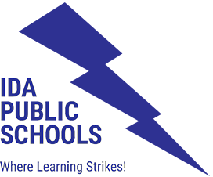

IEMC Student A
Junior Year/ 3rd Year
English 3
Physics
Gov’t/Econ
Math (Geom/Alg 2/Pre-calc)
2-4 Dual Enrollment Class

Senior Year /4th Year
English 4
Senior Sem/Fin Lit
Math(Alg 2/Pre-calc)
Elective
2-6 College Classes

Graduation Ceremony
5th Year at MCCC
MCCC Math Class 1st Sem
8-10 College Classes
IEMC Celebration
Diploma 2028

12-20 MCCC classes
(36-60 MCCC Credits)



IEMC Student B
Junior Year/3rd Year
English 3
Physics
Gov’t/Econ
Math (Geom/Alg 2/Pre-calc)
Elective
Elective

Senior Year/ 4th Year
English 4
Senior Sem/Fin Lit
Math(Alg 2/Pre-calc)
Elective
Elective
2 College Classes
Graduation Ceremony
5th Year at MCCC
MCCC Math Class 1st Sem
8-10 College Classes
IEMC Celebration
Diploma 2028

10-12 MCCC classes
(30-36 MCCC Credits)

